**CLOUD** **COMPUTING**

**Assignment** – **2b**

Name : Sanmat Sanjayakumar Payagoudar

SRN : PES1UG20CS385

Section : G

1. **Section 1: Installation**

1a - Minikube running successfully 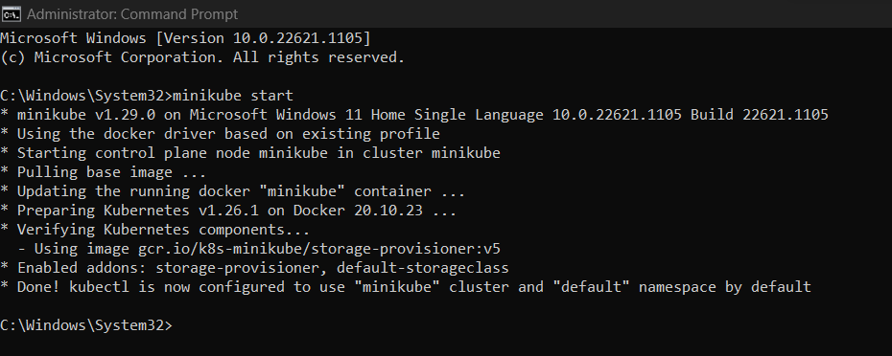

1. **Section 2: Creating pods and deployments, Editing them and observing Rollback**

2a - get nodes, pod and services command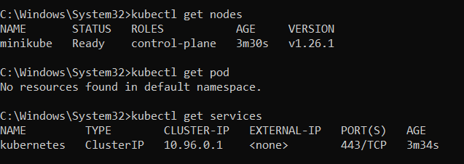

2b- Deployment created

2c- get deployment and pod command

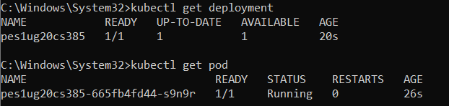

2d- editing ‘-image:nginx.’

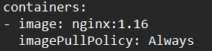

2e- showing edited deployment

2f- deployment is rolled back



2g- showing original nginx image

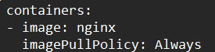

1. **Section 3:Debugging Pods**

3a - Kubectl logs displayed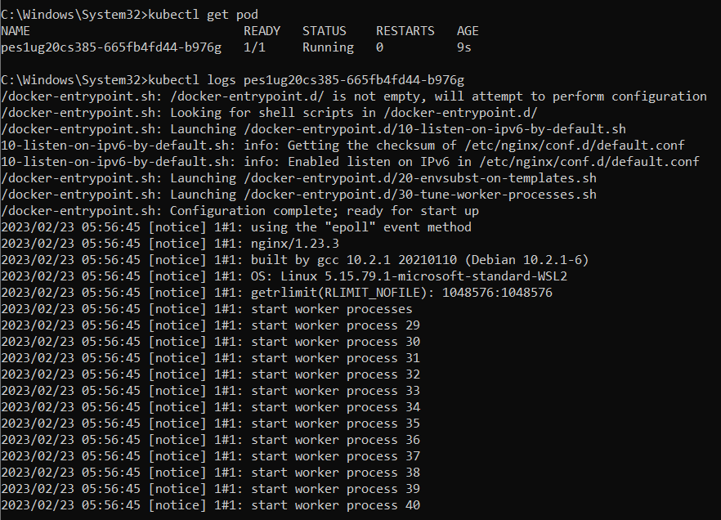

3b- Kubectl ‘describe pod ‘ command

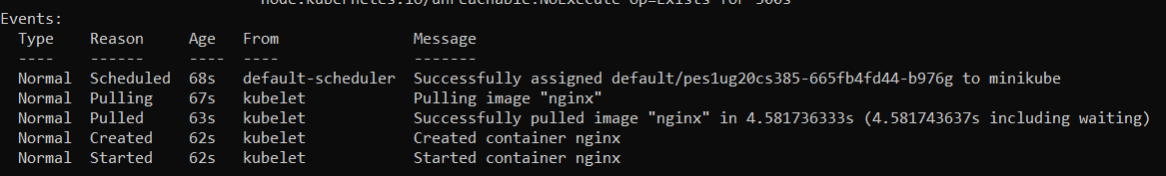

3c - Create mongo deployment

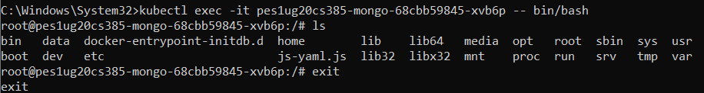

3d - Delete both requirements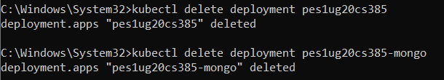

1. **Section 4: Applying configuration files**

4a - Kubectl apply command on yaml file

4b- Kubectl get on yaml file 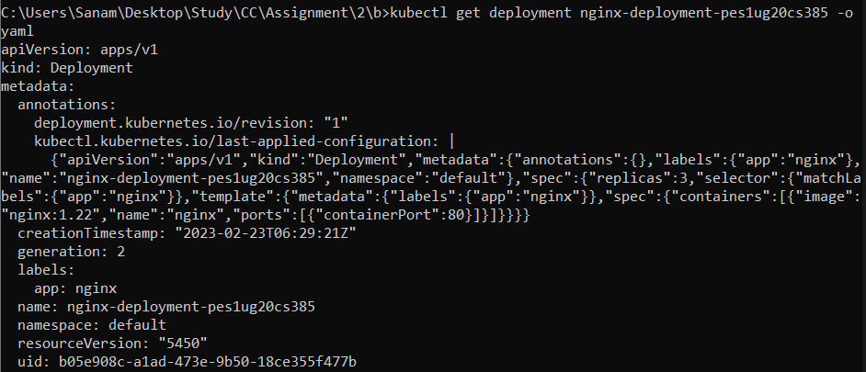

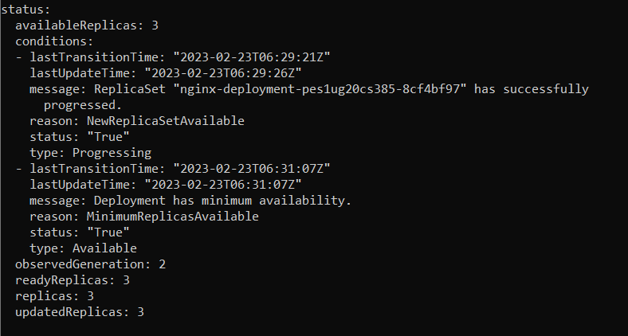

1. **Section 5: Delete a pod to observe the self-healing feature**

5a - Deleted pod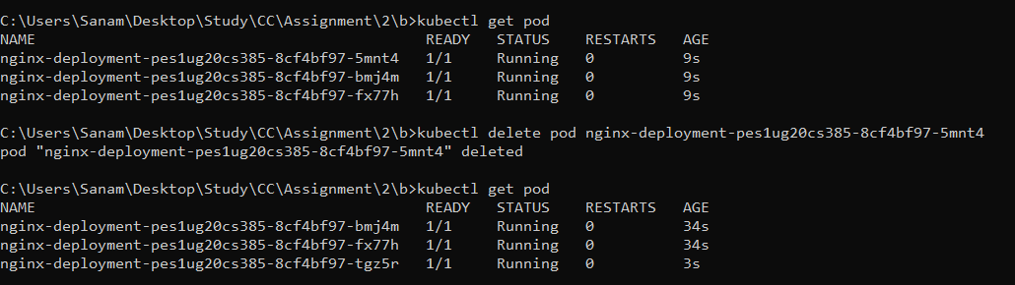

1. **Section 6 : Connecting Services to Deployments**

6a- Kubectl apply and get command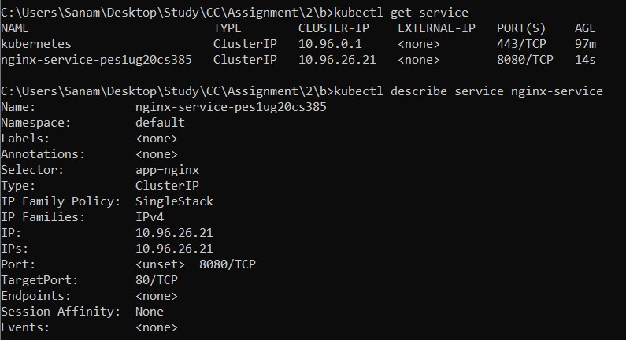

6b-kubectl get pod -o wide command 

1. **Section 7: Port Forwarding**

7a -Kubectl port-forward command 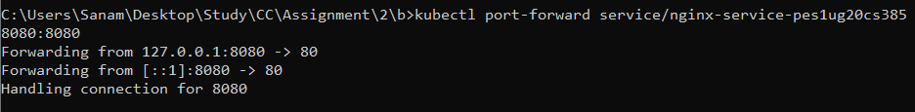

7b- Display welcome to nginx on web page

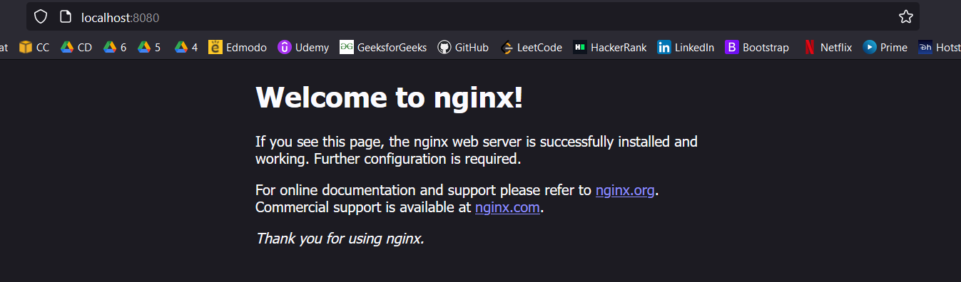

1. **Section 8: Deleting service/deployment and Cleanup**

8a - Delete nginx deployments 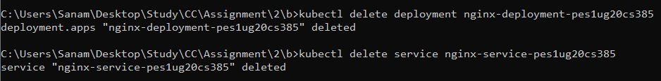

8b - Stop minikube

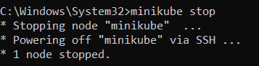

1. **Section 9: Expose an external IP address to access an Application in a cluster**

9a - Screenshot of the command which exposes specifies the type of service (NodePort)



9b - Screenshot of kubectl get service command which displays the node port

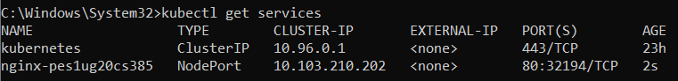

9c - Screenshot of minikube IP address



9d - Screenshot of the webpage with the IP Address visible.

